Scrumptious Ready-to-Bake Cookies for the Holidays!!
Gledhill SACA invites you to bite into a tasty fund-raiser that is perfect for your holiday parties, guest drop-in’s, cookie exchanges, or as an activity to do with the kids over the school break. Guaranteed 100% nut-free, high quality ingredients create delicious treats for your family and your guests and are ready in just a few minutes. As well, the dough freezes nicely so that you can have fresh baked cookies on those “stuck in the house again!” days throughout the coming months. Invite your neighbours and friends to order as well; all proceeds go towards specialty programs for our children such as Scientist in the School, Jungle Sport and Drama with Jeff.
Flavours
Chocolate Chip  Gluten Free Chocolate Chip | - A crispy, melt-in-your mouth sensation, made with lots of pure chocolate chips, creamery butter and farm fresh eggs  - Same delicious ingredients but with GF flour
Oatmeal Raisin | - A chewy treat made with flaky oatmeal, creamery butter, and Thompson seedless raisins
Chocolate Fudge Chip | - Butter-rich chocolate dough combined with pure semi-sweet chocolate chips to create an intense chocolate taste experience
Oatmeal Chocolate Chew | - Chocolate chips, oatmeal and melted butter produce a scrumptious toffee-like sensation
Shortbread  Snappy Ginger | - Fresh creamery butter and pure vanilla give this classic buttery treat its goodness  - Sweet and spicy combine to create the traditional favourite your kids will love
How to Order:
- Simply fill out the attached order form: choose your flavour, your size and your quantity. Make sure to provide your child’s contact information.
  - 1.5L tub will make between 7 – 10 dozen cookies ($15/tub – what a deal!)
  - 500g slice and bake roll will make between 18 – 24 cookies ($8/roll)
- Return your order forms and payment by Monday, Dec. 2nd.
  - Cheques to be made payable to Gledhill SACA.
- Cookie dough will be delivered to your child’s classroom by December 18th. Volunteers are needed for hand-out. If you are interested, please note this on your order form or contact Andrea Page at andreakemppage@gmail.com. THANKS!!!
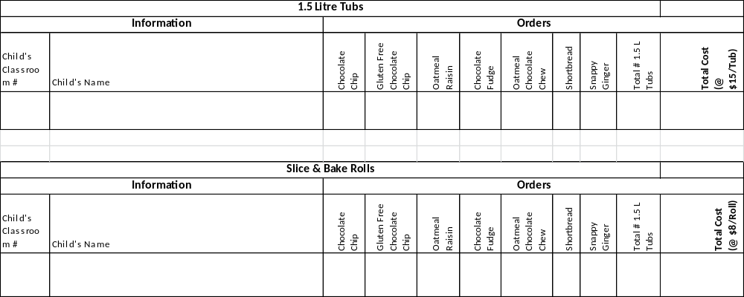

I’d like to volunteer! Name: ____________________________ Email:____________________________________

